Introduction
Support Vector Machine or SVM is one of the most popular supervised learning algorithm which is used for classification as well as regression problems.
However, primarily it is used for Classification problems in Machine Learning.
The goal of SVM algorithm is to create best line or decision boundary that can segregate n-dimensional spaces into classes so that we can easily put the new data point into correct category in future.
SVM algorithm can be used for face detection, image classification, text categorization etc.
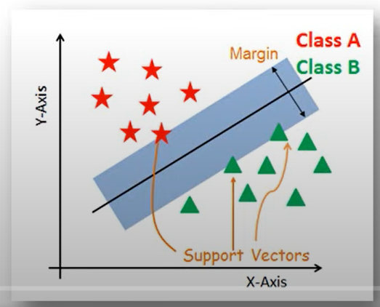
Key concepts of SVM
Support vectors: Data points that are closet to the hyperplane is called support vectors. Seperating line will be defined with the help of these points.
Hyperplane- It is a decision plane or space which is divided between set of objects having different classes.
Margin: It is defined as gap between two lines on the closet data points of different classes.It can be calculated as perpendicular distance from the line to the support vectors.Large margin is considered as good margin and small margin is considered as bad margin.
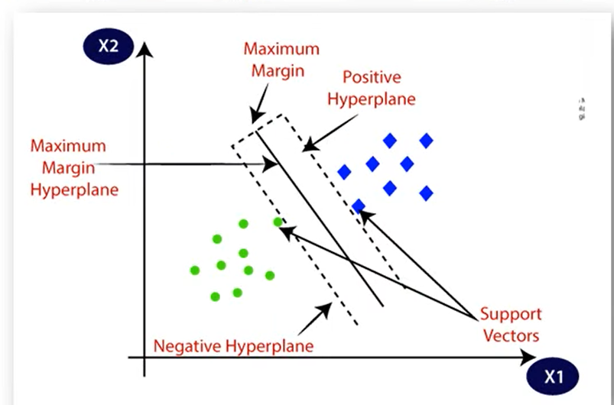
Types of SVM

Linear SVM: It is used for linearly seperable data. Which means if a dataset can be classified into two classes by using single straight line such data is termed as linearly seperable data. And classified used is called as linear SVM classifier.

Non-linear SVM: Non-linear SVM is used for non-linearly seperable data, which means if a dataset cannot be classified using straight line, then such data is termed as non-linear data and classifier used is called as Non-linear classifier.
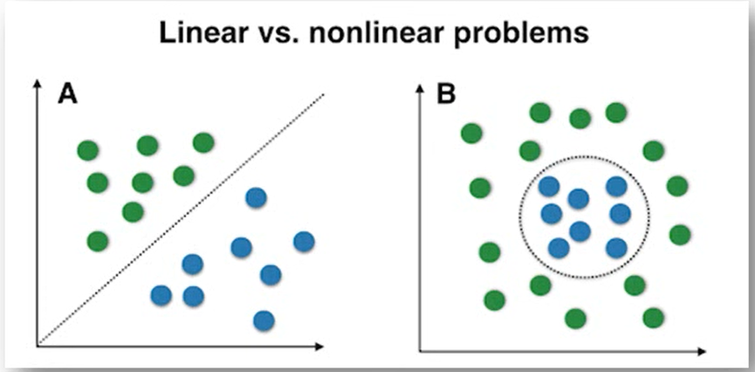

SVM Algorithm Steps
The basic steps of SVM are:
- Select two hyperplanes (2D) which separates the data with no points between them (red lines)
- Maximize their distance (the margin)
- The average line (here the line half way between the two red lines) will be the decision boundary.
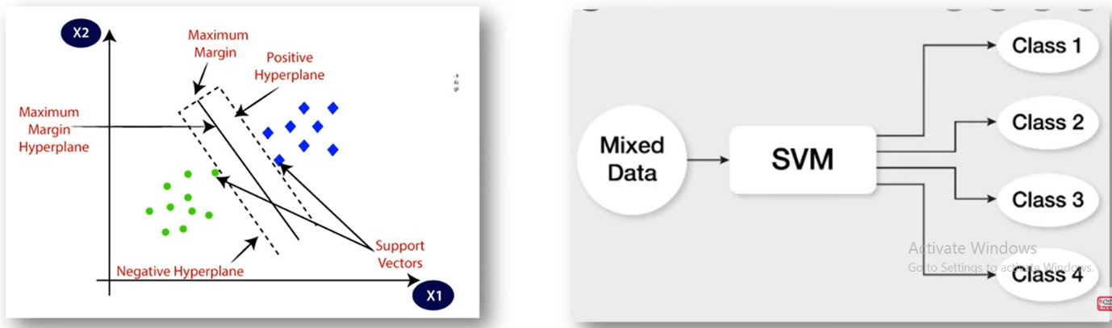

Working of SVM
Scenario 1: Data is linearly separable
Lets consider two classes apple and lemons.
In contrast, SVM will search for apples that are similar to lemons for example apples which are yellow and have elliptical form.
This will be a support vector
The other support vector will be a lemon similar to apple (green and rounded)
So, other algorithms learns the differences while SVM learns the similarities
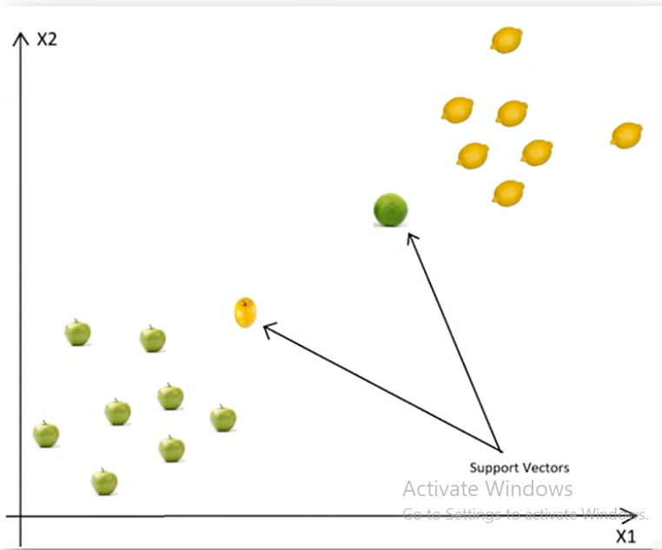

Based on these support vectors algorithm tries to find the best hyperplane that separates classes
SVM will find those two boundary data points or support vectors.
These support vectors should be at maximum margins from optimal hyperplane.
SVM find the two closet support vectors and separate classes with optimal hyperplane.

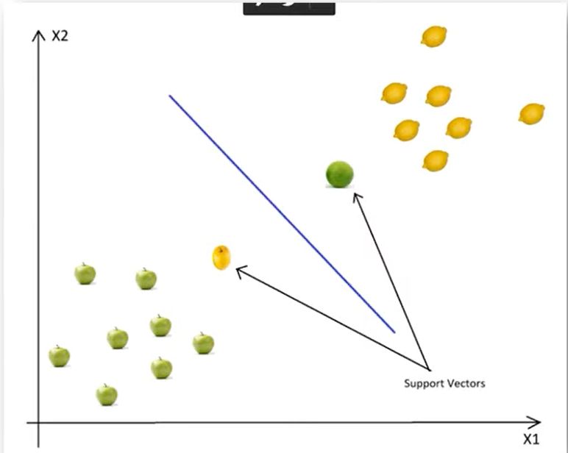

Finding optimal Hyperplane
The best line is the lines that is far away from both apples and Leamon example (has largest margin)
To have optimal solution we have to maximize margin in both the ways.
All in all, Support vectors are data points that defines position and margin of the hyperplane
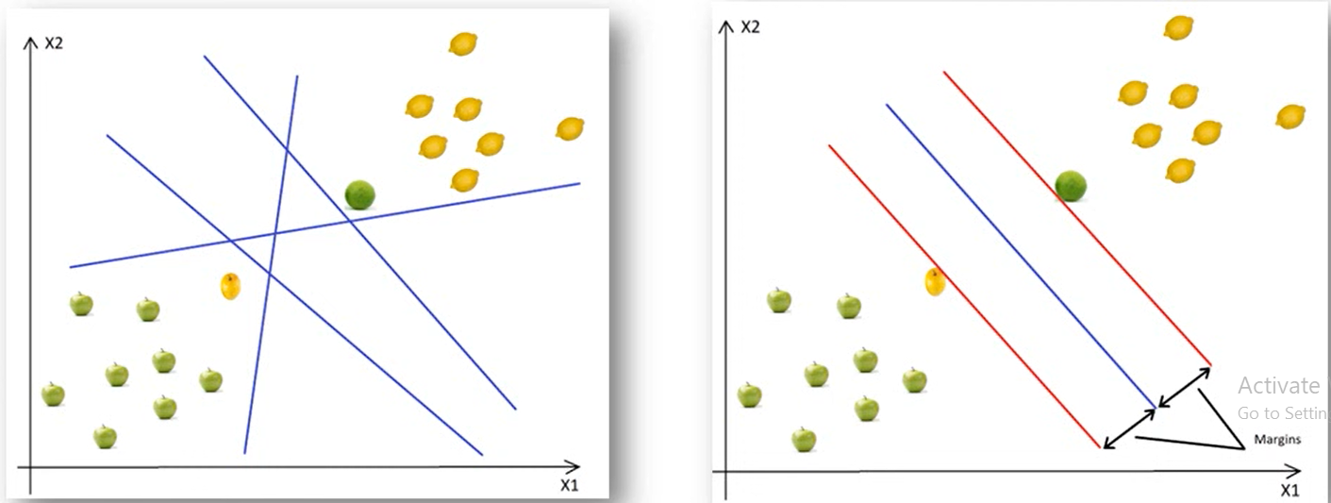

Scenario 2: Data is not linearly separable
In this case we cannot find straight lines to separate apples and lemons.
We will use the kernel trick!
The basic idea is that when dataset is inseparable in current dimensions, add another dimension, maybe that is the way data may be separable.
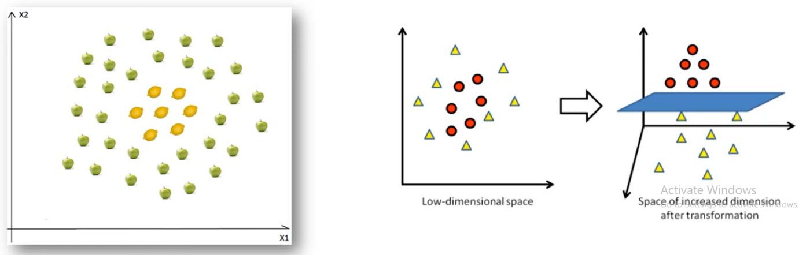

About SVM Kernel
“Kernel” is used due to set of mathematical functions used in support vector machines provides windows to manipulate the data.
It converts low dimensional space to high dimensional space.
To separate non-linear data, kernel is used
Let us assume that we add another dimension x3
Another important transformation is that in the new dimension points are organized using this formula ${{(x}_{1})}^{2}$+${{(x}_{2})}^{2}$
These transformations are called kernels.
Popular kernels are: Polynomial kernel, gaussian Kernel, Gaussian Kernel, Radial Basis Function(RBF), Laplace kernel and sigmoid kernel etc.
Some of these kernels are used in image classification, text classification etc
Mapping from 1D to 2D
After using kernel transformation is happen
So, after transformation, we can easily delimit the two classes using single line
The middle line is called as decision boundary and they classify the data. Kernel have a particular mathematical function and they apply that mathematical function to the dataset and they classify the data into the two classes. In these way one dimensional data is converted to two-dimensional data and it is classified according to its features.
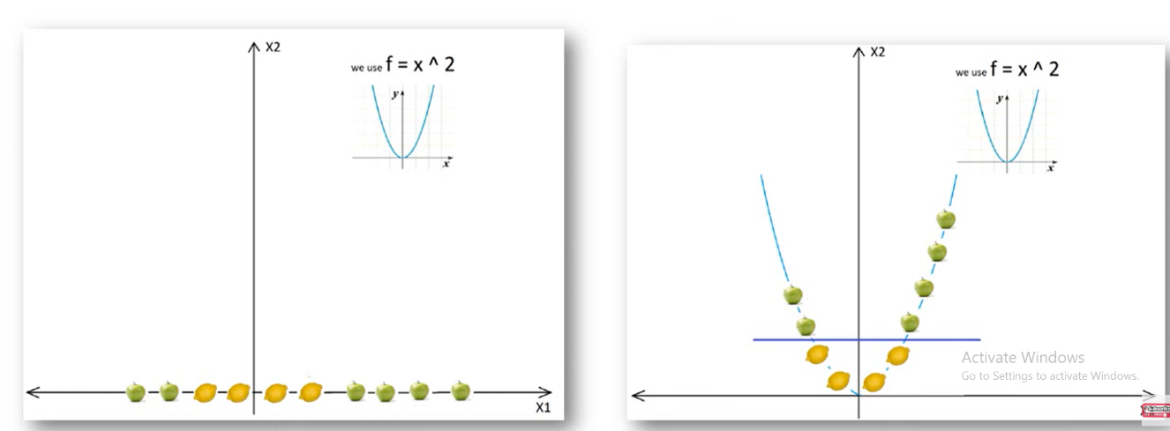

Mapping from 2 D to 3 D
The basic idea is that when a data is inseparable in the current dimensions, add another dimension, may be that way the data is separable.
Given example above is in 2D and it is inseparable, but may be in 3D there is a gap between apple and lemons, may be there is level difference, so lemons are on level 1 and apples are on level 2.
In this case we can easily draw a separating hyperplane(in 3D hyperplane is a plane) between level 1 and level 2.
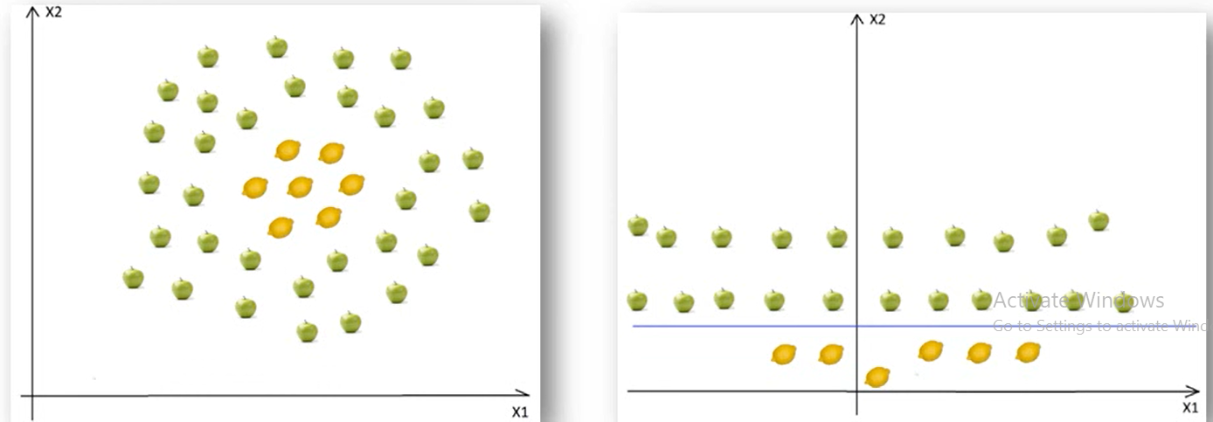

Soft margin SVM
What does soft margin do
It tolerates few dots gets misclassified.
It tries to balance the trade offs between finding the line that maximizes the margin and minimizes the classification.

Two types of misclassifications can happen
The dot is on the correct side of decision boundary but wrong side of the margin
The dot is on wrong side of decision boundary and wrong side of margin.
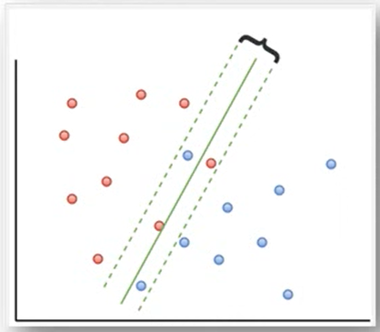

Pros of SVM Classifier
SVM classifier offers great accuracy and work well with high dimensional space.
SVM classifier basically uses subset of training points hence result uses very less memory.

Cons of SVM
They have high training time hence in practice not suitable for large dataset.
It does not work well with overlapping classes.
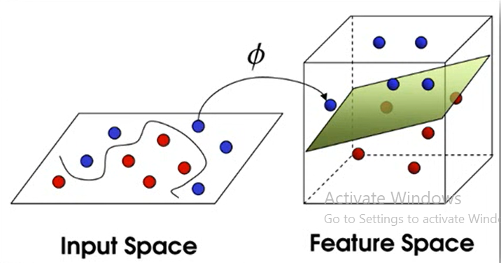

Numerical Solved
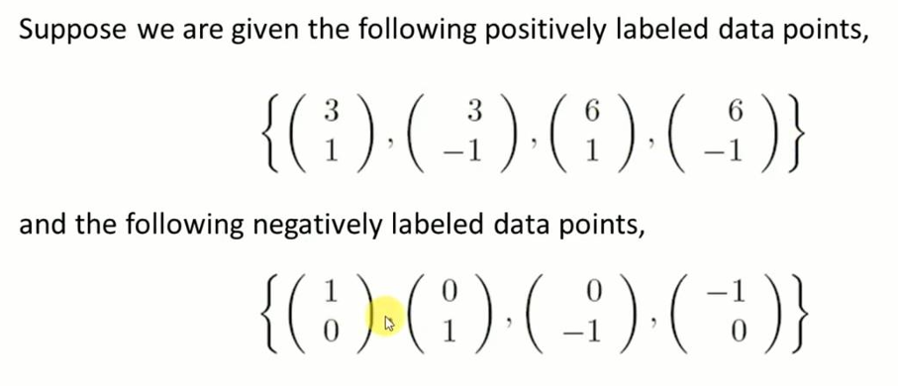

Step 1: Plot the data points on the co-ordinate axes
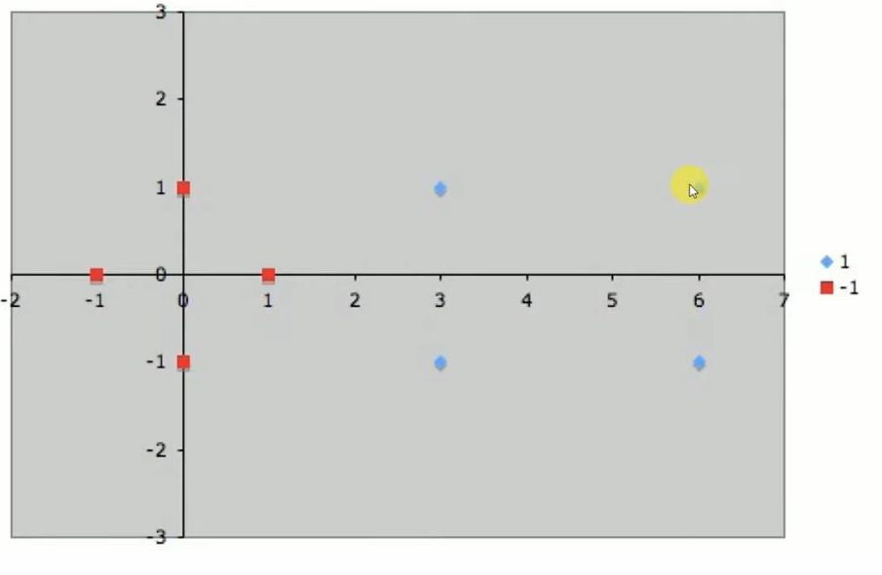

Step2 : Identify the Nearest data point on the either side of the data points
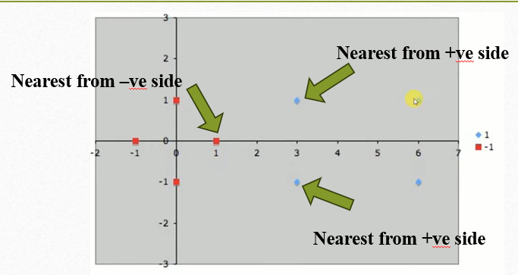
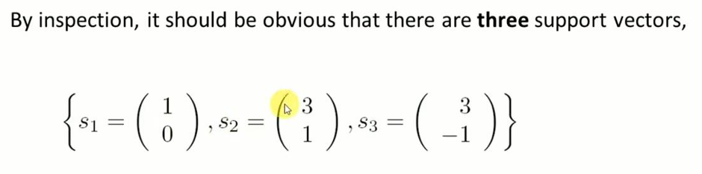
Step 3: Each vector is augmented with bias
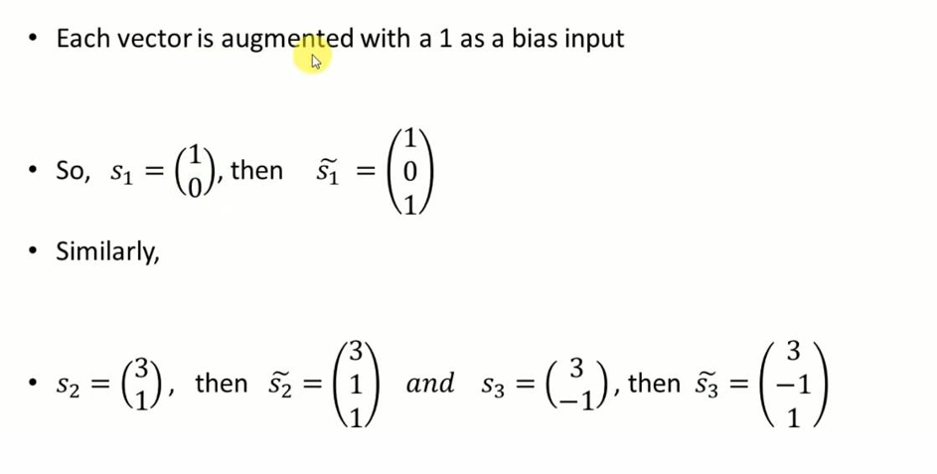

Step4: We need to calculate three variables alpha1,alpha2,alpha3 which will be used to calculate weight variable
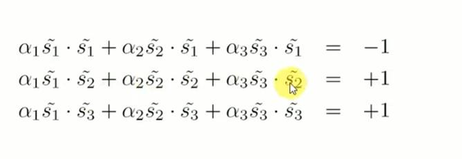
In first equation $s_{1}$ is common and it is on the negative side so it is equated with -1
Second and third equation $s_{2}$ & $s_{3}$ are common and both are on positive side so they are equated with +1.

Step5: Substitute values of $s_{1}$, $s_{2}$ &$s_{3}$ and perform dot product between the two vectors
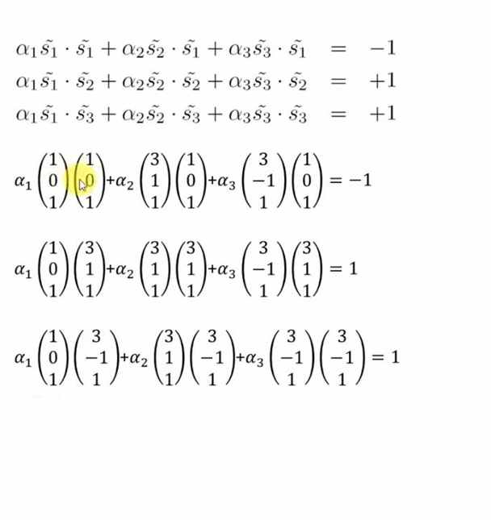
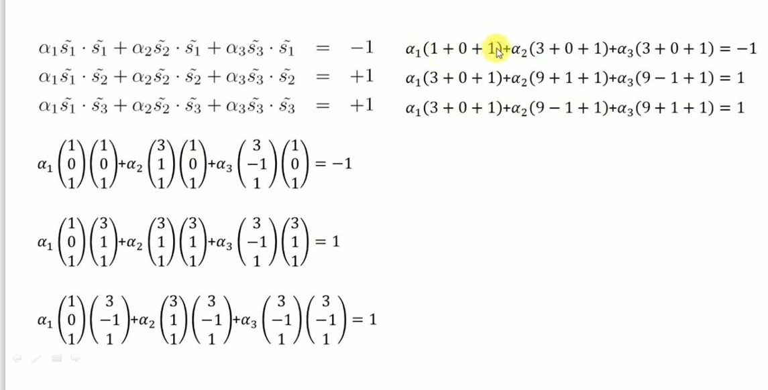

Step6: Solve equation simultaneously and get answer
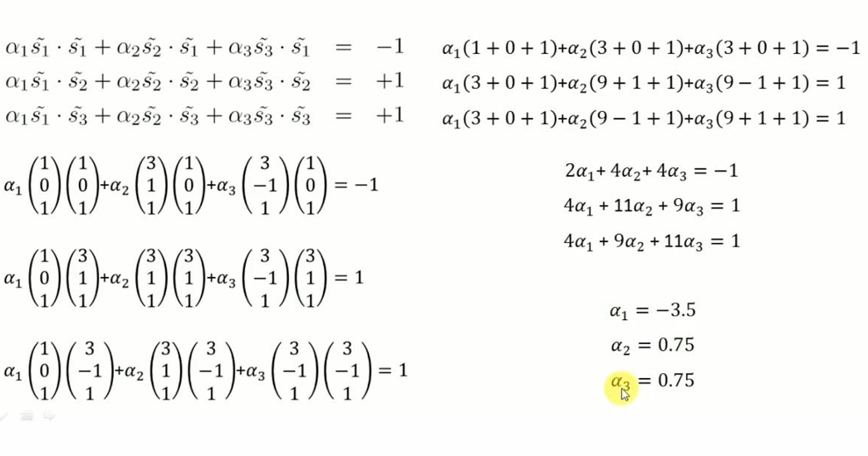

Step 7: Calculate weight and bias information
